POPULATION FORCASTING ANALYSIS

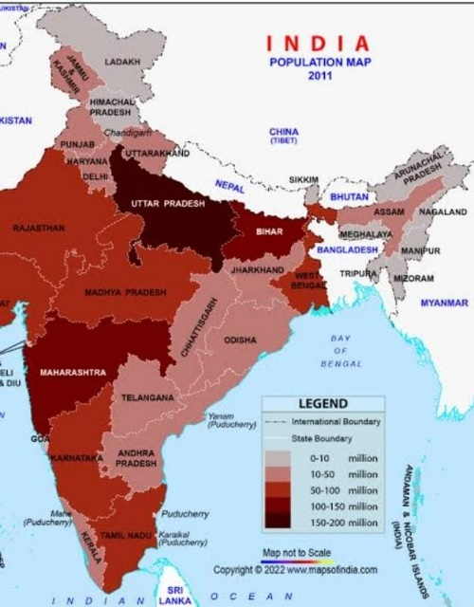

TOPIC : Population Forcasting Analysis

INTRODUCTION

Demographic analysis is an important tool for evaluating census data, particularly in countries where independent sources of data, such as vital registration and sample surveys, are lacking or where a post-enumeration survey (PES) is not conducted. A weakness with demographic analysis is that it generally does not provide enough information to separate errors of coverage from errors in content. Moreover, demographic methods require reliable data on the components of population—fertility, mortality and migration—which are often unavailable. A number of methods are available, and they differ with regard to data requirements, the quality of the results and the technical sophistication required to use them.

OVERVIEW

Population Censuses are generally conducted every 10 years and have as primary objective the total enumeration of the population of a country to provide essential information on their spatial distribution, age and sex structure, and other key social and economic characteristics

PURPOSE

Population analysis is needed to identify problems and community needs, establish goals and objectives, assess alternative courses of action, allocate resources for plan implementation, and evaluate the ability of the plan to achieve goals and objectives.

PROBLEM DEFINITION & DESIGN THINKING

Empathy Map

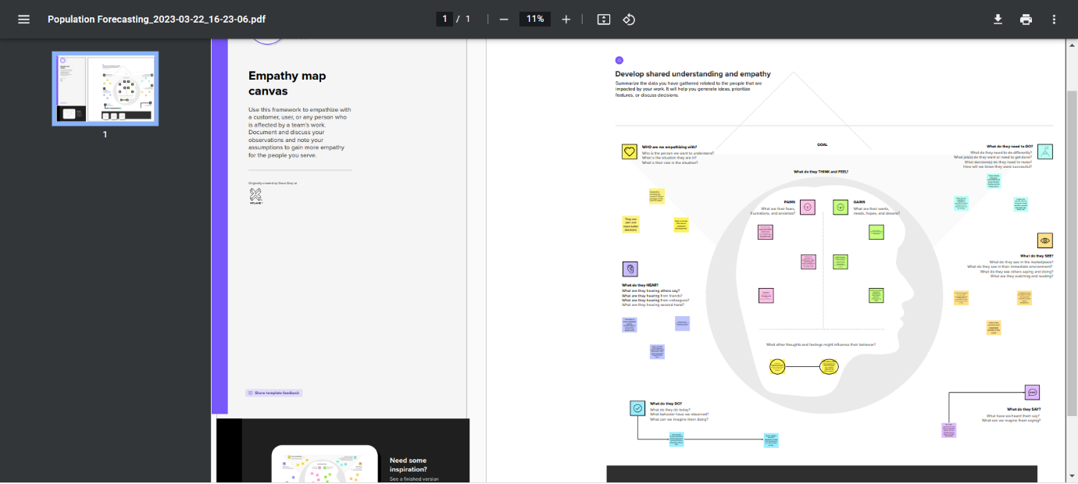

Brainstorming Map

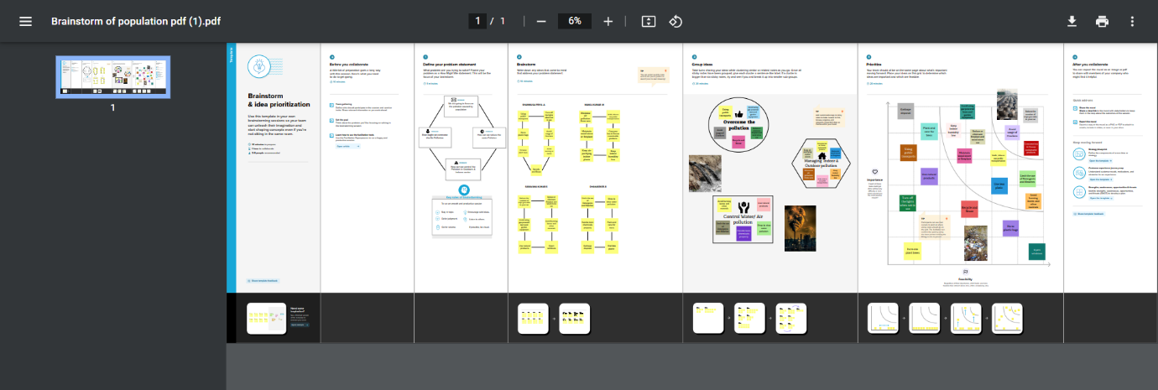

RESULT

Results of a census may be compared with data from other demographic systems, such as vital registration of births and deaths and net migration, if such data are available

ADVANTAGES

1. More people leads to greater human capital. If there are more people, the probability of finding a genius like Einsterin, Marie Curie, Beethoven increase. These exceptional people can lead to technological and cultural masterpieces which enrich our lives. The past 200 years have shown exponential growth in technical development and innovation. There are many factors behind this, but the world’s growing population means we have a bigger pool of human capital and the possibility of these cutting edge discoveries increase.

2. Higher economic growth. Population growth will lead to economic growth with more people able to produce more goods. It will lead to higher tax revenues which can be spent on public goods, such as health care and environmental projects.

The obvious evaluation is to say, the crucial thing is not GDP, but GDP per capita. If economic growth is at the same rate as population growth, average living standards will not increase. However, it is possible population growth can also improve per capita incomes. As the population increases, the economy can benefit from a bigger talent pool, economies of scale and greater specialisation. All this can enable higher per capita income, which we have seen in major developed economies.

3. Economies of scale. Farming and industry have been able to benefit from economies of scale, which means as the population grows, food output and manufacturing output have been able to grow even faster than population growth. For example, at the turn of the nineteenth century, Thomas Malthus predicted population growth would lead to famine as we would be unable to feed the growing population. However, his dire predictions failed to materialise because he failed to understand, that the productivity of land, labour and capital could all increase more than proportionately. 300 years ago, most of the population worked on the land. Technological innovation and economies of scale, mean productivity of land has vastly increased as farmers make use of mechanisation and economies of scale for increased food production.

4. The efficiency of higher population density. In terms of per capita carbon footprint, areas with a high population density are significantly more efficient than rural areas and places with a low population. When people live in densely populated areas, they are more likely to use public transport, live in apartment buildings which are easier to heat. In big cities, transport and the delivery of goods is much more efficient, whereas for low population densities, the average cost and environmental footprint are much higher. Therefore, population growth which leads to growth in city connurbations (which is a feature of global growth in past) is not as environmentally damaging as we may think. In Green Metropolis, by David Owen he argues living in closer proximity in cities is a key aspect of sustainability

Urban areas account for only 3% of the world’s land surface. But, more than 50% of the population. By 2050, the United Nations predict this will rise to 70%. Therefore, population growth doesn’t have to lead to an equivalent fall in natural habitats.

5. The improved demographic structure of society. Many western economies are now experiencing a falling population, with the result that their population demographic is being skewed to old, retired people. This is imposing costs on society as we struggle to pay for health care and pensions. Moderate population growth helps to rebalance the population with a higher share of young, working people.

6. Critical mass. Higher populations can enable a critical mass of people to enable a sider, more vibrant society. With low populations, there is less scope for diversity. But, when the population grows, it can enable the support of a broader cultural range of activities.

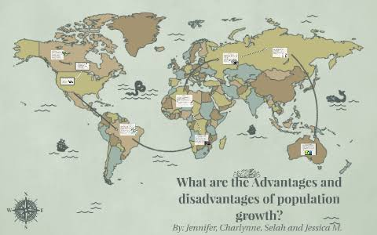

DISADVANTAGES

1. Cost to the environment. Population growth exacerbates many of the existing environmental problems

Trying to reduce carbon and methane emissions to reduce global warming is relatively more difficult as the population.

There will be greater threat on natural habitats as a greater population has greater demand for housing and farmland. This will increase pressure to cut down forests to make way for farming and housing.

Higher population will lead to a greater consumption of non-renewable resources, leading to a faster depletion of natural resources.

Higher population will lead to greater pollution levels in air, water and land. Higher pollution is associated with a range of health issues, such as cancer and asthma. The pollution also harms animals and plants.

Soil degradation. To feed a growing planet, we have seen serious degrading of farmland (according to UN estimates) about 12 million hectares of farmland every year. This is due to factors, such as overgrazing, use of chemicals, climate change and use of chemicals.

2. Congestion. Too many people in a small space will lead to various types of congestion. Road congestion is a major problem across the world. One study suggested congestion cost the EU €111bn (1% of GDP) in 2012. WIth population growth, the costs of congestion will only increase leading to time lost, more pollution and lost output.

3. Water shortages. Already up to 40% of the world’s population face water scarcity and the risk of drought. According to the UN water shortages could lead to 700 million people at the risk of displacement. A growing population will put pressure on scarce water supplies and this is a factor behind many minor and major conflicts with countries having to find ways around the shortage of water.

4. Generating unsustainable waste. We are currently generating non-biodegradable rubbish that we are struggling to process. It tends to end in landfill, causing methane emissions and other toxic problems.

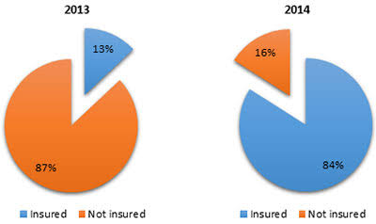

APPLICATIONS

The first step is to analyze the situation carefully to learn more about the problem. A single situation may solve multiple problems. Identify each problem and determine its cause. Try to anticipate the behavior and response of those affected by the problem.

Then, based upon your preliminary observation, use the following tips to pinpoint the problem more accurately:

Separate facts from opinions

Determine the process where the problem exists

Analyze company policies and procedures

Discuss with team members involved in order to gather more information

Define the problem in specific terms

Gather all the necessary information required to solve the problem

While defining a problem at this stage, make sure you stay focused on the problem rather than trying to define it in terms of a solution. For example, “We need to rewrite the training documents” focuses on the solution rather than the problem. Instead, saying, “Training documents are inconsistent” is a better way to define a problem.

Depending upon the complexity of the problem, you may want to use tools, like flowcharts and cause-and-effect diagrams, to help define the problem and its root

CONCLUSIONS

ConclusionWe, humans, often forget how we are going to suffer if the population keeps exploding. If the number keeps rising, then it will be difficult to survive. Citizens need to understand the negative impact of the population explosion. Taking the right measures and keeping the resources in mind will help to control the population.

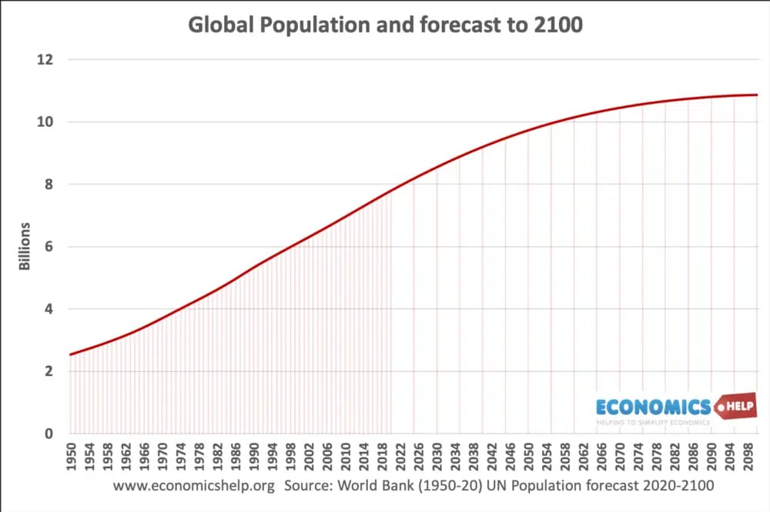

FUTURE SCOPE

Development of ARCADE is on-going, and there is still much to do. The author currently has a list of some 100 enhancements planned for the future. These vary from trivial to very complex.

For example, there is currently no special software for editing the configuration files describing the structure of the laboratories and the student details! These are stored in text files and carefully altered with a standard text editor.

A new feature, which has in fact just been added but not yet used, allows the manager to specify certain module sessions as having a `Non-Registered' group. This contains all of the people who in fact are not registered to take that module, but who might suddenly decide to. This will be invaluable for the first few weeks of a new semester when the students keep changing their options: at least there can be somewhere ready printed to record their marks until things settle down.

Another planned feature, which is related to the above, is a mechanism for informing each student, again by email, of the details which the system database has about him or her. This would be sent automatically as it changes, so the student can check the accuracy. Experience has shown that

students are not always quick to recognize the need to tell their department that they are intending change modules, for example, and this leads to much confusion.

APPENDIX

Source Code

Source code is generally understood to mean programming statements that are created by a programmer with a text editor or a visual programming tool and then saved in a file. Object code generally refers to the output, a compiled file, which is produced when the Source Code is compiled with a C compiler

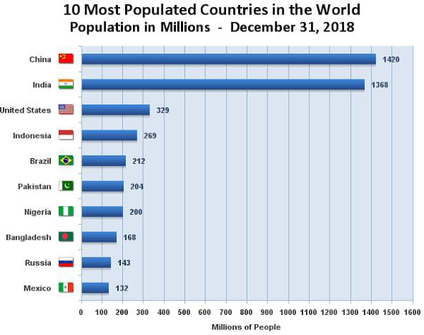

SOURCE CODE :

**https://drive.google.com/file/d/1BaE5nitL_Bjl-IMpL6BydenVhxBTxIZk/view?usp=drivesdk**